Unable to set the safety code

Author: 胡心怡
Reviewer：Eason

FAQ\Hybrid INV
Issue introduction
The INV is unable to set the safety code after the first installation.
Confirmation of basic information
[Photo]SN number of the inverter and battery.
[Photo]Inverter screen display.
Guidance for installer
Step1: Select another safety code to see if it can be saved successfully. If it can, this indicates a network delay; you can then switch back to the correct safety code.
Settings path: Setting→Advanced Setting→Safety
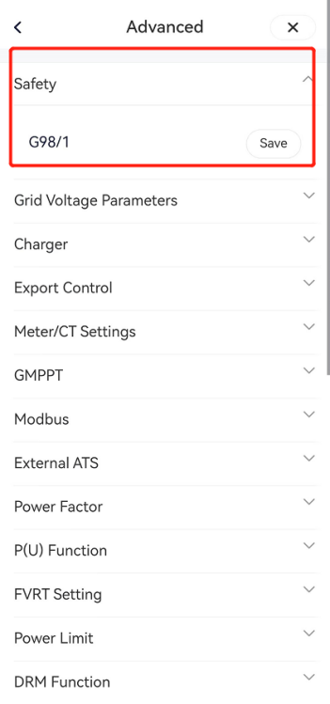
Step2: If the safety code cannot be saved, confirm that the DC Switch is flipped to ‘ON’. Then, use a multimeter to measure the PV voltage. Make sure within MPPT rang of the inverter.
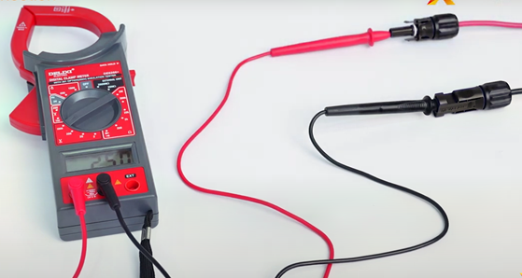
If the system includes a battery, please refer to the user manual to ensure that the battery switch is properly turned on. The inverter screen should display <Normal>.

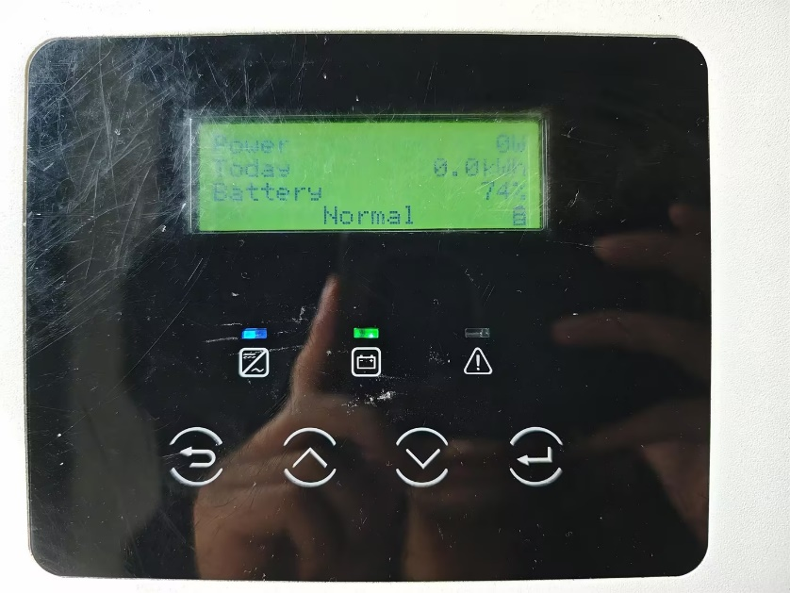
Step3: Turn the DC switch to 'OFF' to disconnect the PV, turn off the battery, and disconnect the grid power. Wait for the inverter screen to turn off for 15 seconds, then turn on all switches and wait for the inverter to return to <Normal> status before setting <Safety> again.
Information check list
If you have completed the above <Guidance for installer>, and the problem is still not solved, please collect the following troubleshooting information and send them to the R&D.
1.[Photo]Inverter information including SN and registration number.
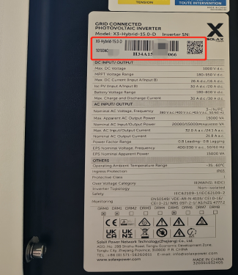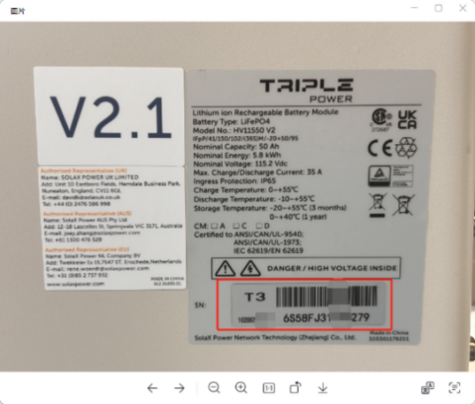
2.[Photo]PV voltage.

3.[Photo]inverter screen.


